**Student:**

**Student ID:**

**Course Section Number:**

**WEB PROJECT**

**REPORT**

**[SKKU FLEA MARKET]**

# For All Users – Create an account & log in

## [Register Page]

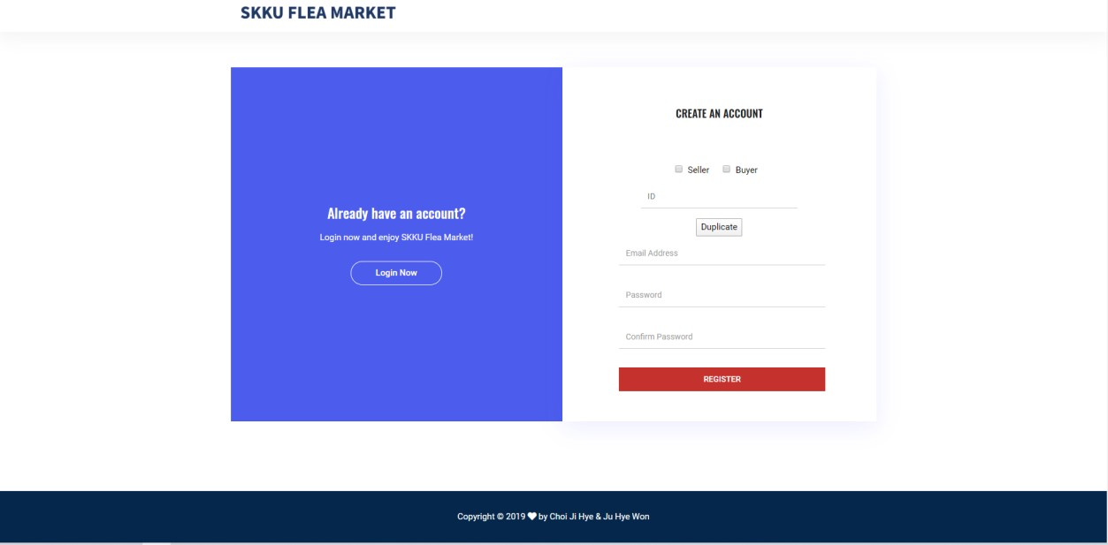

[Main Function]

* Select seller or buyer to register: You can choose user type as seller or buyer with a checkbox.
* Check id duplicate: The duplicate button checks whether the id is already in the database. But same id and different user types can be allowed to register this web page.
* Check password and confirm password: We will check the password and confirm the password is the same.
* Check no blank form when register clicked: If the user doesn’t fill all form and click the Register button, it happens register fail alert. So, the user should fill all forms.
* Create an account: If the user success creates her/his account, he/she can log in and enjoy our website.
* Move to the login page: If the user clicks the “Log in now” button, the user can move to the login page. **[Login Page]**

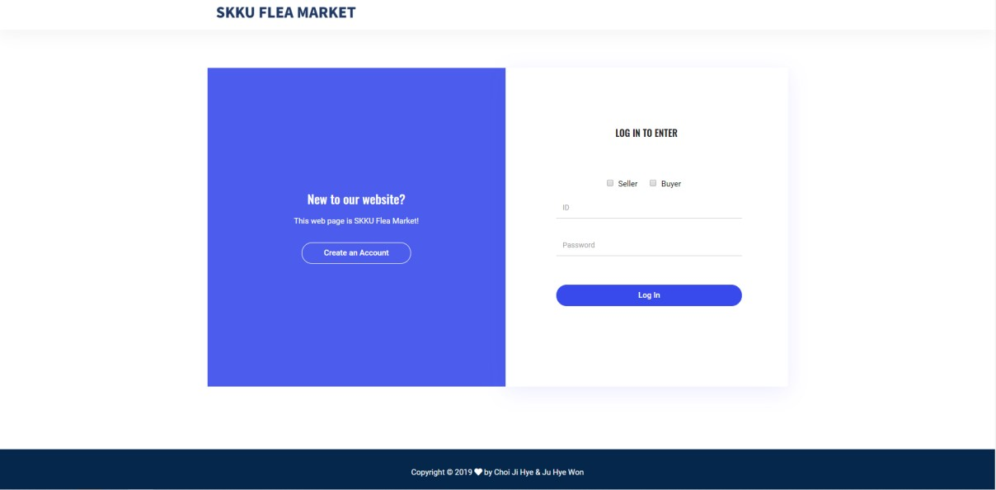

[Main Function]

* Select seller or buyer to register: You can choose user type as seller or buyer with a checkbox.
* Check no blank form when login clicked: If the user doesn’t fill all form and click the login button, it happens login fail alert. So, the user should fill all forms.
* Check id & password: If id and password information does not match in the database, it will alert login fail.
* Move to the register page: If the user clicks the “Create an Account” button, the user can move to the register page.
* Success Login: If the user success in login, the user can move to the home page as the user type. However, if the user does not check the user checkbox, and enter the id = admin, PW = admin, the user can move to the administrator page.

# For Administrator – Manage member List

## [Member List Page]

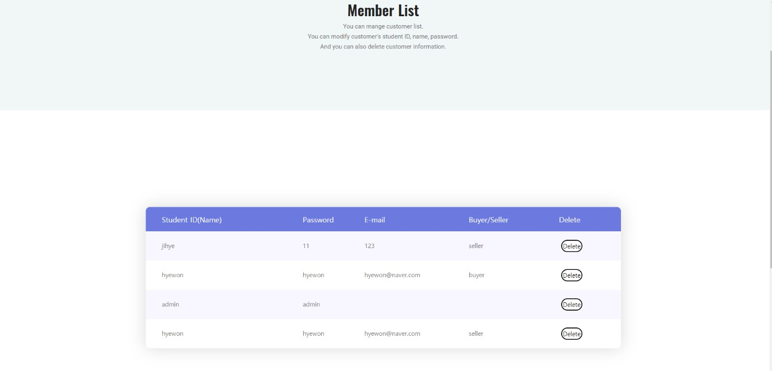

[Main Function]

* Check the member list: On the administrator page, the administrator can check all member's information.
* Modify member’s account information: If the administrator clicks the table’s member-specific information (ex. phone number, user type, name, etc), the administrator can modify its information.
* Delete member information: If you click the “delete” button, it confirms if you want to delete it. So, if you answered yes, its row will delete on the table and DB.
* Save member list change: If you click the “save” button, all change things will be saved on the database.

# Pages for Sellers

## [Home Page]

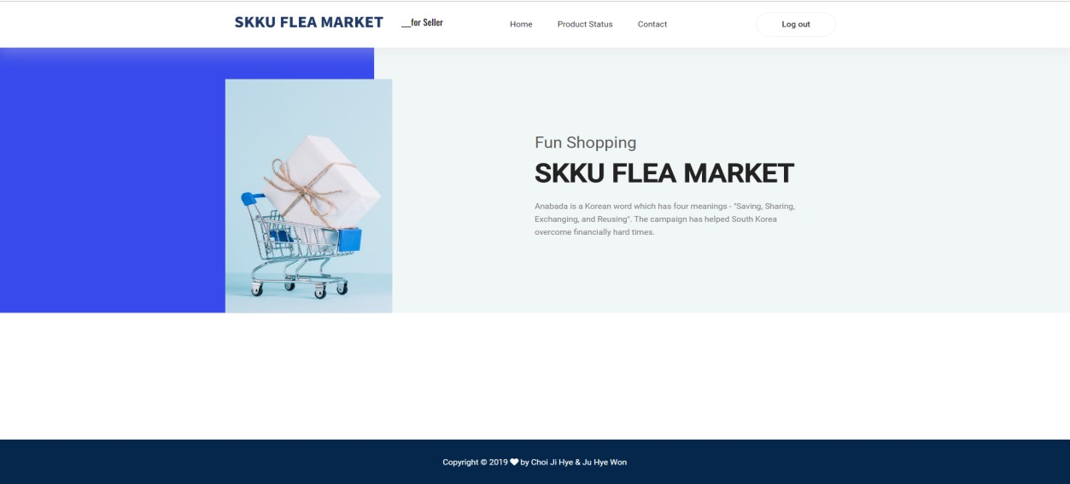

This is the home page for sellers. We show the page for seller and buyer differently.

And you can move other pages from the navigation bar which consists of product status, contact us page. Also, if you click the logout button you can log out from our web and you can move to the login page.

## [Upload Product Page]

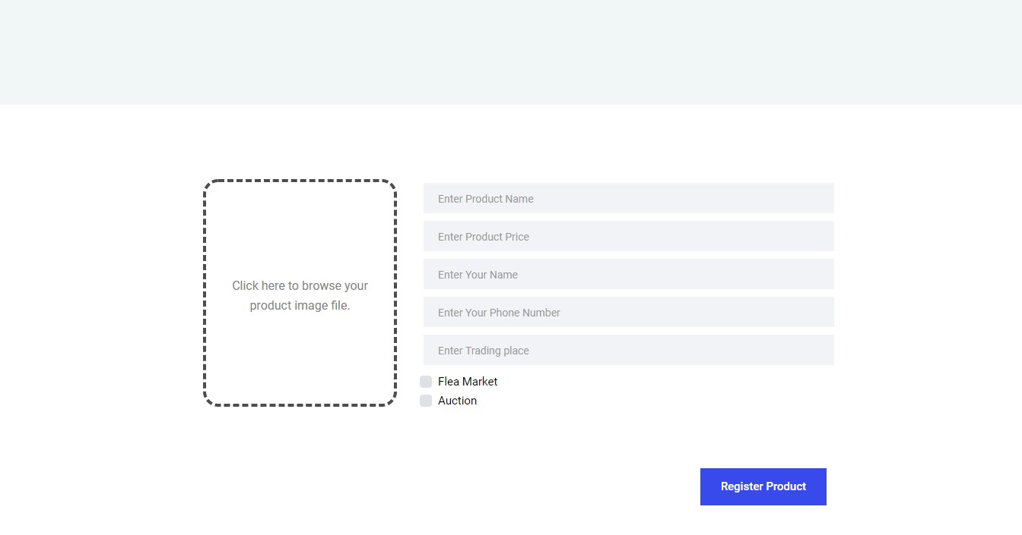

[Main Function]

* Upload the product: Seller can upload the products.
* Upload the product’s image: The seller can upload the product’s image. when the seller clicks the box on the left side, the seller chooses the file in file lists. And then when the seller selects the file, the file will be shown in this box area. And the product’s image is upload to the database.
* Check no blank form: The seller must set the product name, product price, and seller’s name, seller’s phone number, trading place. when the Register Product button is clicked, If the seller doesn’t fill all forms and click the Register Product button, it alerts there is a blank field.
* Check the Selling mode: Seller can choose to sell mode in Flea-Market or Auction.
* Auction mode checkbox’s hidden function: When the Auction mode’s checkbox is clicked, the due field is shown. this due field is saved into the database. it can be used to calculate auction end time.

## [Last Page]

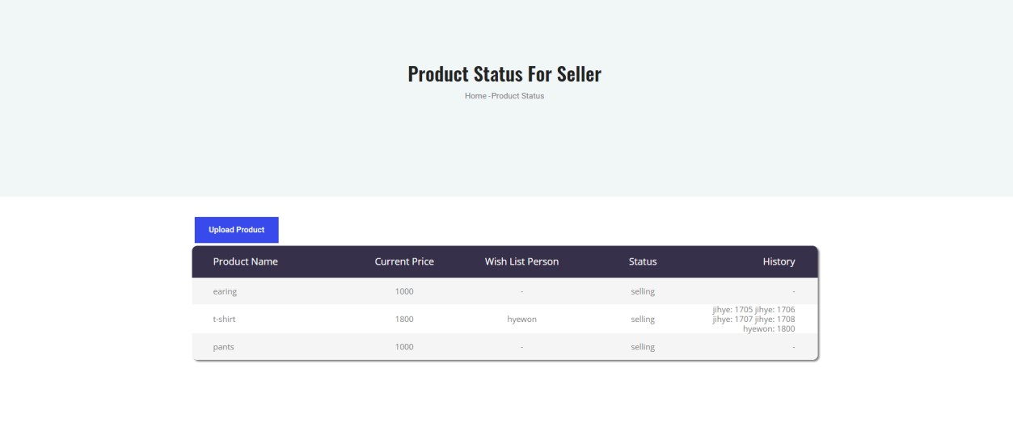

[Main Function]

* Upload Product Button: this button loads the upload product page.
* Product list: Seller can see all the product whether its status is selling or sold out and whether it is auction mode or flea-market mode.
* Current Price: In Auction mode, the current price is the highest price suggested by buyers.
* Status column: this status column means the product’s status. ( selling or sold)
* History column: When the product’s selling mode is an auction, the history appears. in the history column, there is all buyer’s name who participate in this auction and their suggestion price.

-

## [Contact Page]

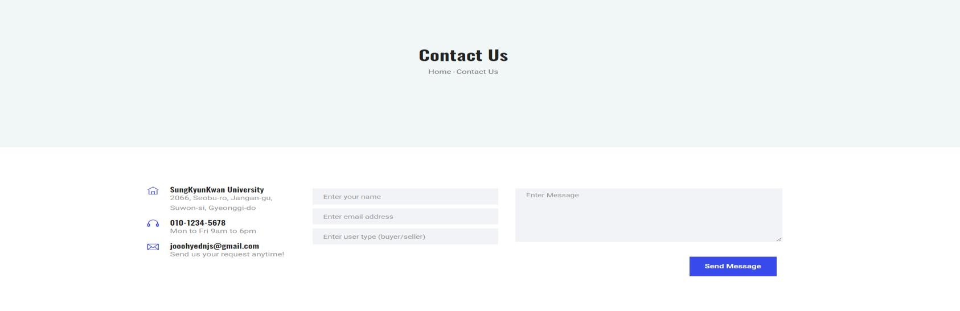

This is the contact page. On this page, users can contact us by leaving a message.

These messages are stored in our database.

# Pages for Buyers

## [Home page]

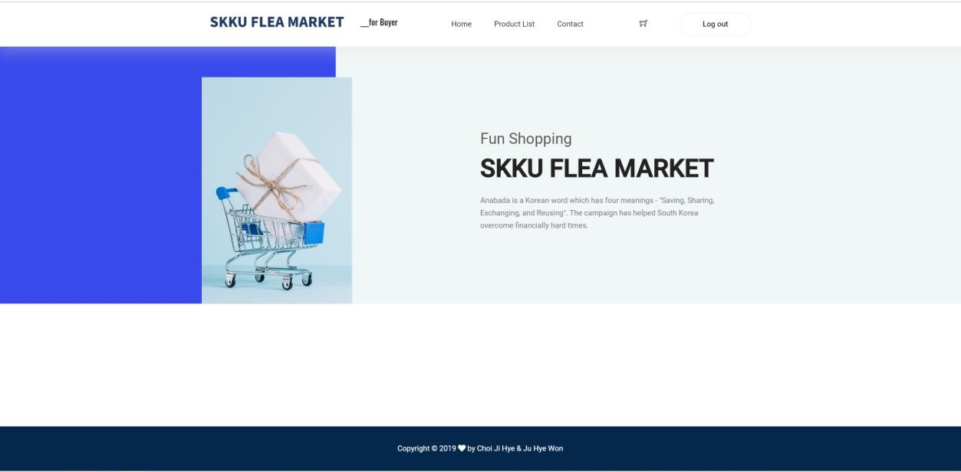

This is the home page for the buyer.

We show the page for seller and buyer differently.

And you can move other pages from the navigation bar which consists of the product list, contact us page. Also, if you click the logout button you can log out from our web and you can move to the login page.

## [Product List Page]

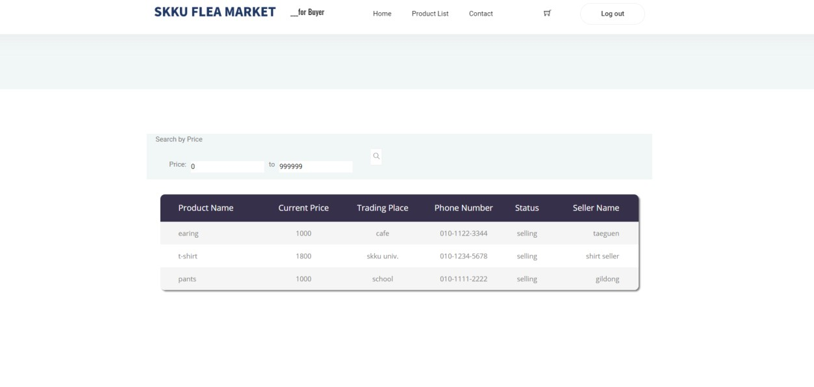

[Main Function]

* Check all product List: On this page, the buyer can see all the products.
* Sold Item: If the user clicks the table row for product detail and its status is “sold”, it will alert can not buy its item.
* Product detail page: When the buyer clicks the table’s row, the detail page will be shown. It is divided into two versions auction and flea market. If the clicked item’s type is flea market, you can move to the product detail page with flea market format (vise versa).
* Search Product with a price: Buyer can search the product by price. You can set a minimum and maximum price in the search bar. And if you click the “search” icon, you can see the products which match your price condition. The product list is ordered by price.

## [Product Detail Page]

When the buyer clicks the product ‘s list, the detail page will be shown. The detail page is different from the mode (auction or flea market).

## [Product detail page – Auction]

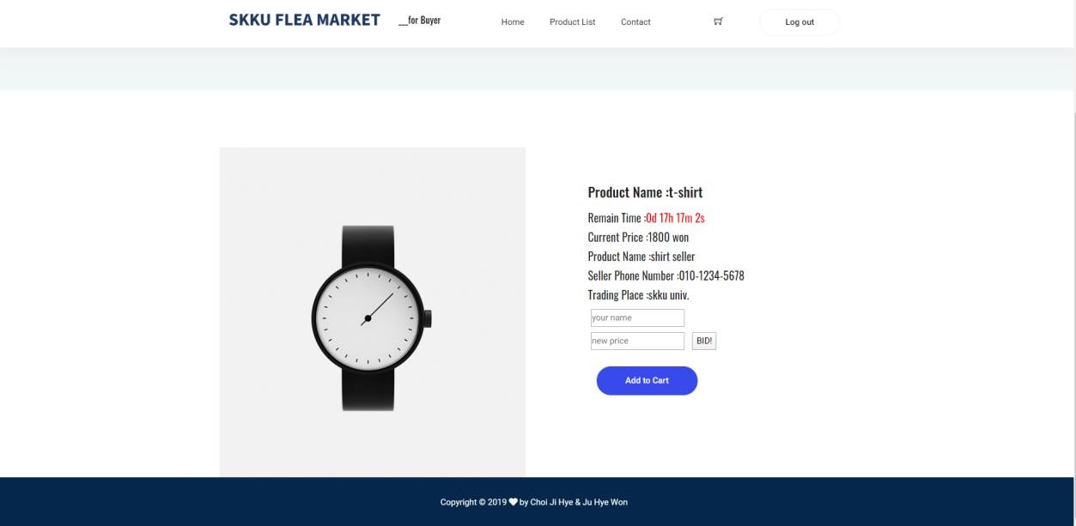

[Main Function]

* Product information: If the user clicks the item row on the list page, this page will be shown

the item information. This page consists of a product name, product price, product seller name, product seller phone number, product trading place.

* Remaining time: The time count is shown, showing that the difference between the deadline selected by the seller and the current time is reduced by one second.
* Price bidding: If the user bids higher than the current price, the current price is uploaded and linked to the database. If you bid higher than the current price, you will be alerted to success. But if you bid lower or the same price, you will be alerted to bid higher.

## [Product detail page – Flea Market]

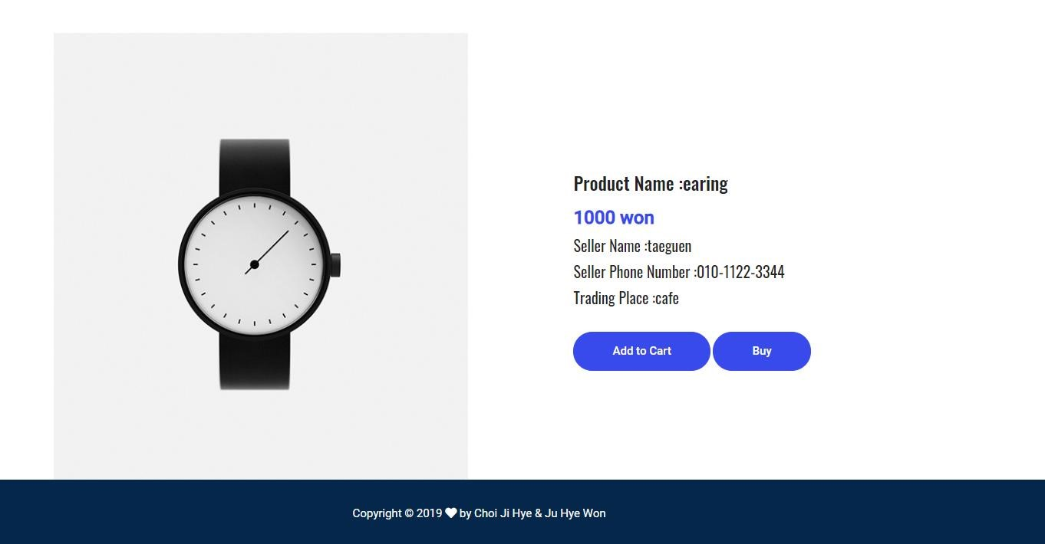

[Main Function]

* Product information: If the user clicks the item row on the list page, this page will be shown the item information. This page consists of a product name, product price, product seller name, product seller phone number, product trading place.
* Buy product: The user can buy the product by the ‘buy’ button. When the user buys this product, the product’s status will change to sold status. This change is updated as soon as the buyer buys the product. Also, the database will be changed.

## [Contact Page]

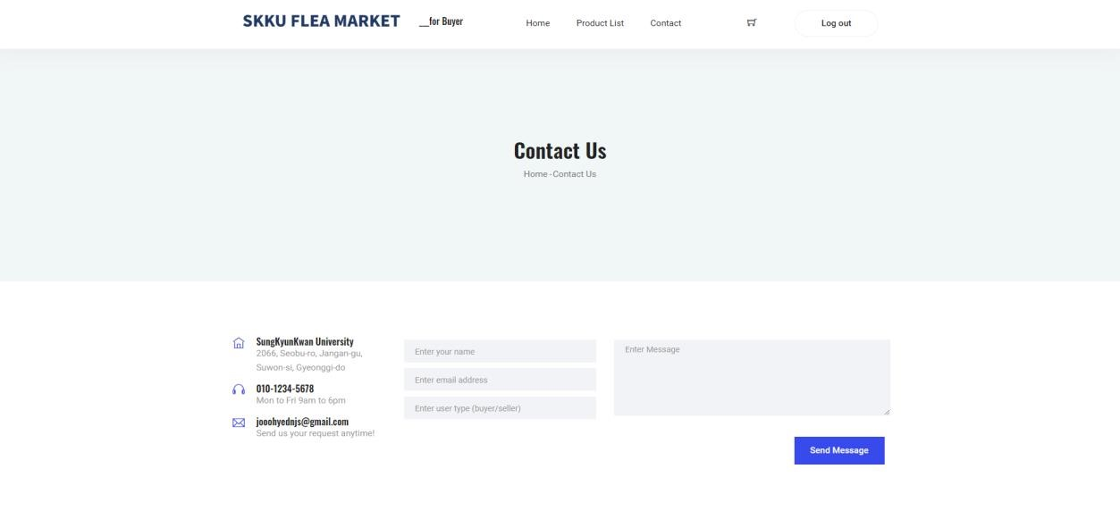

This is the contact page. On this page, users can contact us by leaving a message.

These messages are stored in our database.

# Database with firebase

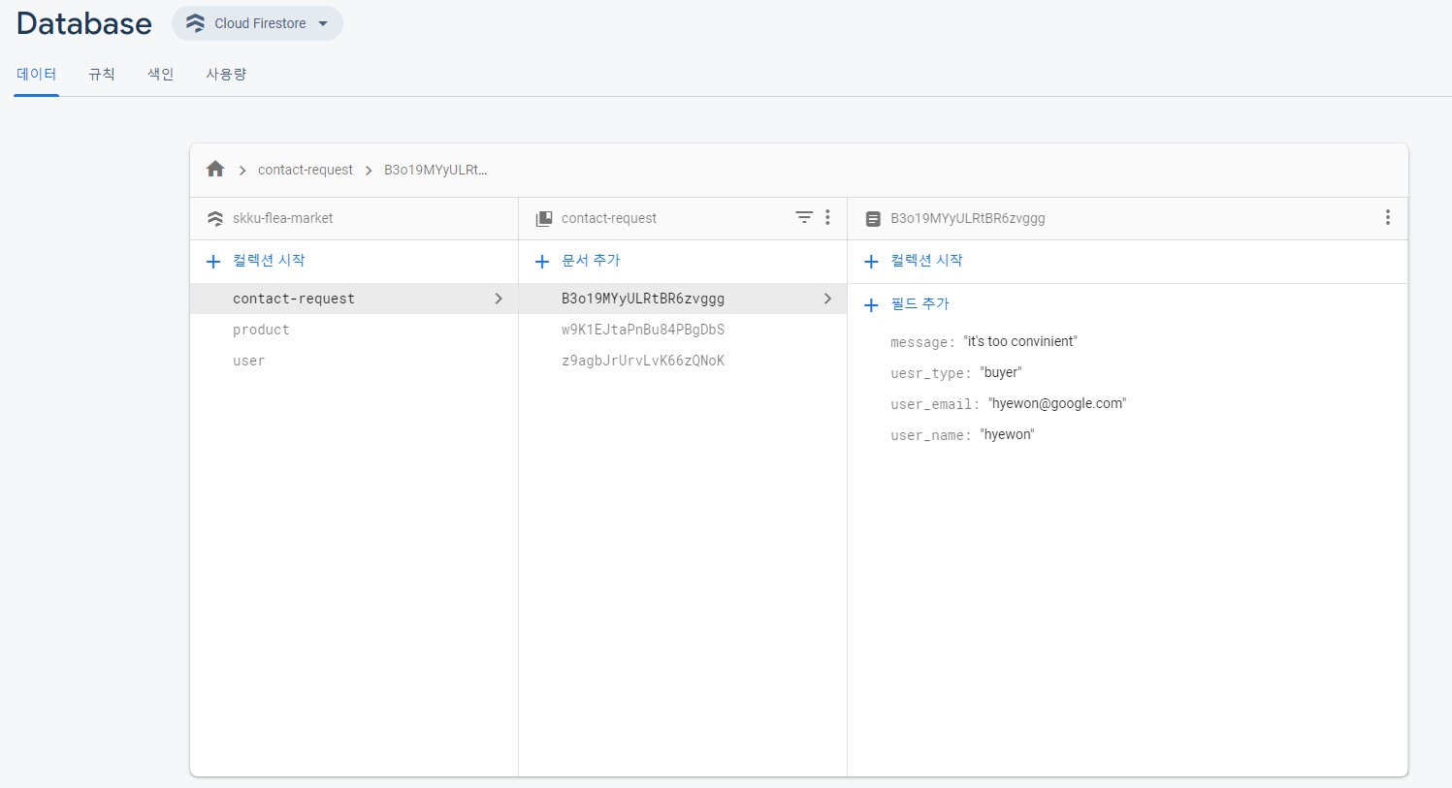

# Code History

You can check the development history in our Github link.